**Problem Description**

In Low Middle Income Countries (LMIC) there is an alarming number of post-operative deaths compared to High Income Countries (HIC). Postoperative care is the care given after a surgical operation and deaths during this time are usually a result of inefficient care. For example, an emergency abdominal surgery in Africa has a postoperative mortality rate two times higher than HICs (Ng-Kamstra et al., 2018), regardless of the patient’s physiological factors that may support survival. Further statistics show that in LMICs, 18.2% of patients experience postoperative complications, 10% of which die, meaning 1 out of 100 patients die from postoperative complications (Biccard et al., 2018). The main reason behind these deaths are due to inadequate surveillance of wound care (Uribe-Leitz et al., 2016). Focusing on this factor can reduce the chance of postoperative deaths in LMICs.

Inadequate surveillance is an issue that stems from high nurse-to-patient ratios. In LMICs the nurse to patient ratio is 1:32, which is significantly higher than the ratio in HICs (Assaye et al., 2018). Due to the high demand, nurses can easily become overwhelmed and miss symptoms that patients may express, leading to conditions like sepsis. Thus, it is important for healthcare professionals to have adequate surveillance of the patients to combat these high postoperative mortality rates (Uribe-Leitz et al., 2016). In order to address problems throughout admission, surgery, and recovery (the perioperative period), The PERI System can help.

**Solution Concepts**

PERI is a low-budget technological system that assists nurses in prioritizing patient requests. Because LMICs may have a lack of resources, limited electricity, and cellular/WIFI dead zones, the solution is designed to be inexpensive, functional without consistent power, and locally hosted. PERI consists of Raspberry Pis with distinct roles: The Sending Pi (SP) and the Receiving Pi (RP). Raspberry Pis are palm-sized, inexpensive, single board computers, which will be used to host PERI’s software. In the case of power outages, Pis and their monitors will run off of continually charged, portable power banks. In order to reduce the need for expensive network infrastructures while combating cellular/Wi-Fi dead zones, Pis will communicate using a series of ethernet cords and hubs.

The SPs will be placed by each patient’s bed and displays 3 main buttons to click on: *Pending Care, Immediate Care, Urgent Care*. Underneath each main button, are detailed sub-buttons that give the nurses more specific information as to the patients’ needs. After a button is clicked, the request is sent to the nurses’ RPs where it is prioritized in relation to other requests so that nurses can efficiently process and fulfill tasks. Once completed, each task can be removed from the RPs’ tables.

PERI is designed specifically for LMICs and intended to be used by stakeholders such as nurses, doctors, patients, non-profit organizations, clinics, and hospitals. The system meets the needs of these stakeholders, because it is inexpensive, runs on limited electricity, and is locally hosted, without requiring any WiFi or cellular data. PERI will assist nurses in prioritizing their tasks and reduce postoperative deaths, benefiting every listed stakeholder.

**Reduction to practice**

In the tested environment, PERI’s proof of concept is confirmed, such that the Raspberry Pis can communicate with each other through ethernet connection without any additional Wi-Fi/cellular support. In the experimental test, the sub-buttons *Food, Mild Pain,* and *Leaking Bodily Fluids,* were clicked on the SP to simulate detailed patient requests. The main buttons *Pending Care, Immediate Care,* and *Urgent Care* were also clicked to demonstrate general, prioritized patient requests. Figure 1 displays the test set-up with an SP being connected to an RP by ethernet, and their displays being computer monitors. Figure 2 is the interface of the SP, whereas Figure 3 is the interface of the RP. As a result of the test-case, the patient requests that were clicked on SP are displayed on RP in prioritized order.

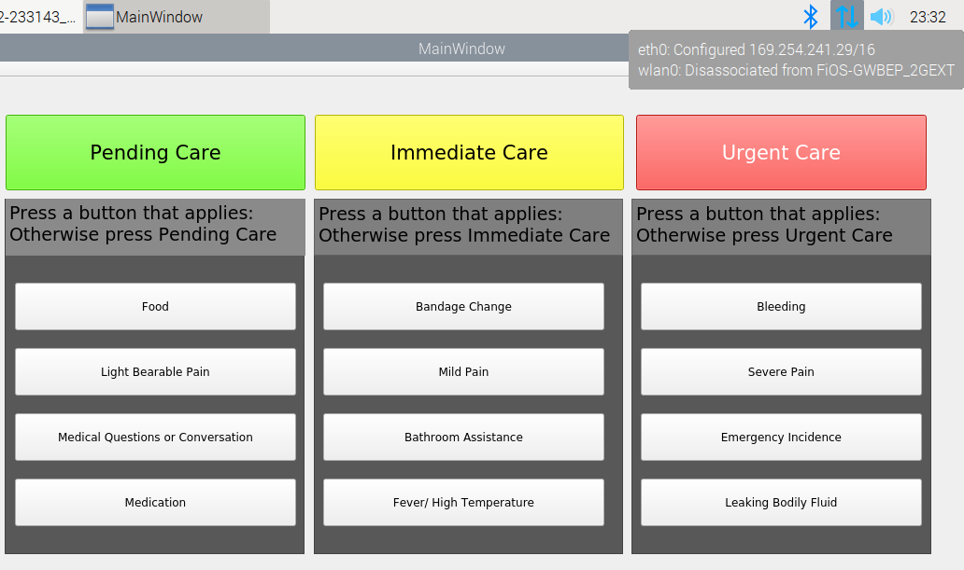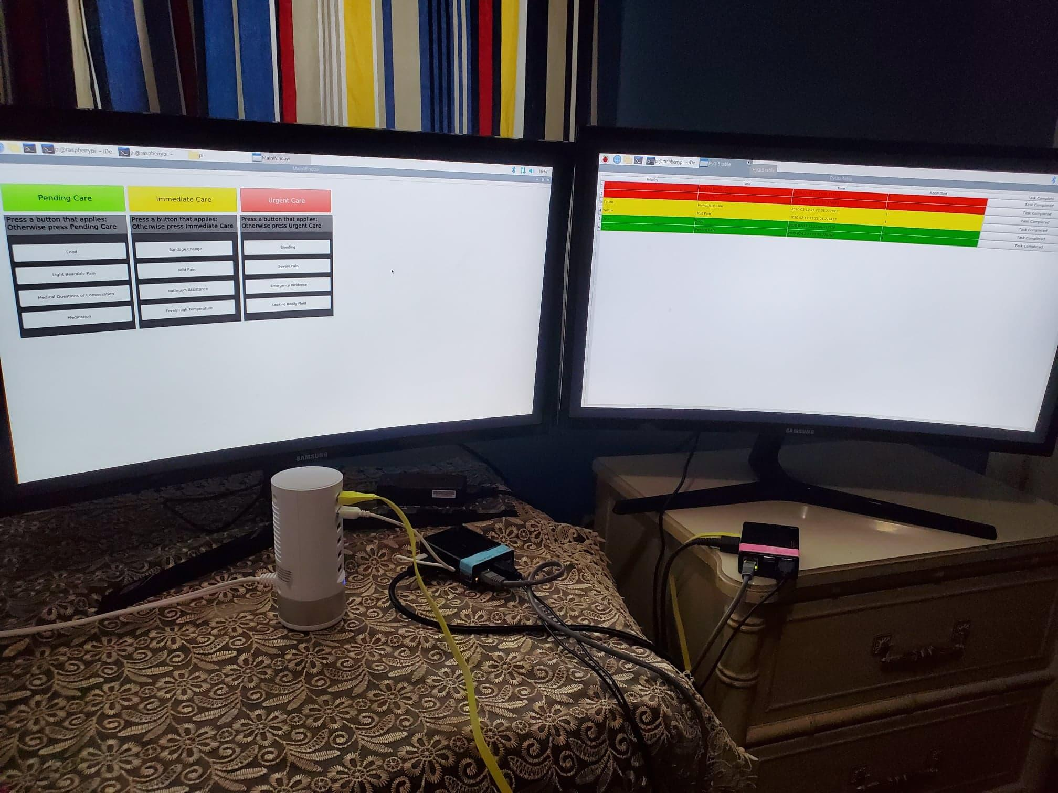

*Figure 1 - Test Set-Up with Connected Pis Figure 2 - Sending Pi Interface*

*Figure 3 - Receiving Pi Interface, Prioritized Requests*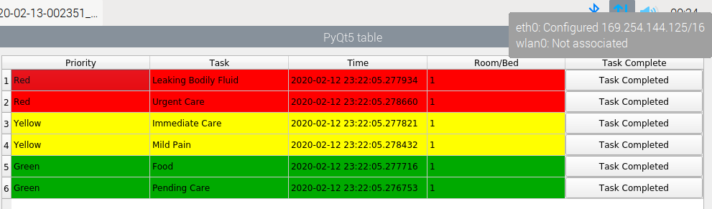

**Pathways to Implementation**

The pathway in order to successfully and impactfully implement PERI includes further additional hardware and real-world stress testing. Multiple Pis, Ethernet hubs, Pi monitors, and portable battery packs, are some of the things that need to be tested in order to mirror the infrastructure and layout of actual clinics/hospitals. For example, there should be one SP for each bed and one RP for each nurse. The implementation of PERI also needs to consider how many SPs are directed to one RP for the most efficient, organized and non-overwhelming strategy to serve patients and reduce postoperative deaths.

**References**

Assaye, Ashagre Molla, et al. “Impact of Nurse Staffing on Patient and Nurse Workforce Outcomes in Acute Care Settings in Low- and Middle-Income Countries: A Systematic Review Protocol.” *JBI Database of Systematic Reviews and Implementation Reports*, vol. 16, no. 12, Dec. 2018, pp. 2260–67. *DOI.org (Crossref)*, doi:10.11124/JBISRIR-2017-003707.

Biccard, Bruce M., et al. “Perioperative Patient Outcomes in the African Surgical Outcomes Study: A 7-Day Prospective Observational Cohort Study.” *The Lancet*, vol. 391, no. 10130, Apr. 2018, pp. 1589–98. *ScienceDirect*, doi:10.1016/S0140-6736(18)30001-1.

Ng-Kamstra, Joshua S., et al. “Perioperative Mortality Rates in Low-Income and Middle-Income Countries: A Systematic Review and Meta-Analysis.” *BMJ Global Health*, vol. 3, no. 3, June 2018. *PubMed Central*, doi:10.1136/bmjgh-2018-000810.

[Uribe-Leitz, Tarsicio, et al. “Variability in Mortality Following Caesarean Delivery, Appendectomy, and Groin Hernia Repair in Low-Income and Middle-Income Countries: A Systematic Review and Analysis of Published Data.” *The Lancet Global Health*, vol. 4, no. 3, Mar. 2016, pp. e165–74. *ScienceDirect*, doi:10.1016/S2214-109X(15)00320-4](https://www.zotero.org/google-docs/?2e0Csy)